1:Write a program to create student class with data members rollno, marks1,mark2,mark3.

Accept data (acceptInfo()) and display using display member function.

Also display total,percentage and grade.

1. Create a class Person with data members as name, age, city. Write getters and setters for all the data

members. Also add the display function. Create Default and Parameterized constructors. Create the

object of this class in main method and invoke all the methods in that class.

2. Create a class Date with data members as dd, mm, yy. Write getters and setters for all the data members. Also add the display function. Create Default and Parameterized constructors. Create the

object of this class in main method and invoke all the methods in that class.

3. Create a class Book with data members as bname,id,author,price. Write getters and setters for all the

data members. Also add the display function. Create Default and Parameterized constructors. Create

the object of this class in main method and invoke all the methods in that class.

4. Create a class Point with data members as x,y. Create Default and Parameterized constructors. Write

getters and setters for all the data members. Also add the display function. Create the object of this

class in main method and invoke all the methods in that class.

5. Create a class ComplexNumber with data members real, imaginary. Create Default and Parameterized constructors. Write getters and setters for all the data members. Also add the display function. Create the object of this class in main method and invoke all the methods in that class.

6:create BankAccount aaplication for operations like withdraw ,deposite and moneyTransfer.

Create menu drive program for bank operations..

7:Create Student class with rollno,name address.

Write business logic for auto incrment of rollno(don't accept roll no from user)

Write parameterised constr for accepting name and address only

Write getter and setter and display function

7.1 Test Student class by creating 5 diff object.and display aal details(chk rollno created automatically)

7.2 Create an array of 5 students and show only names

**package** default1;

**import** java.util.Scanner;

**public** **class** TestStudent {

**public** **static** **void** main(String[] args) {

System.***out***.println("Enter student name and address");

Scanner sc=**new** Scanner(System.***in***);

Student s1,abc;

s1=**new** Student(sc.next(),sc.next());

s1.displayData();

Student[] s=**new** Student[5];

**int** index=0,choice=0;

abc=**null**;

System.***out***.println(" 1. Enter new Student 2. Display student details 3. Update name 4. Update address 5. Exit");

**do** {

System.***out***.println("Enter choice");

choice=sc.nextInt();

**switch**(choice) {

**case** 1:

**if**(index<s.length) {

System.***out***.println("Enter Name and address:");

abc=**new** Student(sc.next(),sc.next());

s[index]=abc;

index++;

}

**break**;

**case** 2:

**for**(**int** i=0;i<index;i++)

{

s[i].displayData();

}

**break**;

**case** 3:

System.***out***.println("Enter roll no");

**int** rl=sc.nextInt();

**for**(**int** i=0;i<index;i++) {

**if**(s[i].getRollno()==rl) {

System.***out***.println("Enter new name");

s[i].setName(sc.next());

}

}

**break**;

**case** 4:

System.***out***.println("Enter roll no");

**int** a1=sc.nextInt();

**for**(**int** i=0;i<index;i++) {

**if**(s[i].getRollno()==a1) {

System.***out***.println("Enter new address");

s[i].setAddress(sc.next());

}

}

**break**;

**case** 5:

**break**;

**default**:

System.***out***.println("Wrong choice. Try again ");

**break**;

}

}**while**(choice!=5);

}

}

**package** default1;

**public** **class** Student {

**private** **int** rollno;

**private** **static** **int** *counter*;

**private** String name,address;

**static** {

System.***out***.println("----Static block----");

*counter*=100;

}

**public** Student(String nm,String ad) {

*counter*++;

name=nm;

address=ad;

rollno=*counter*;

}

**public** **void** setName(String n) {

name=n;

}

**public** String getName() {

System.***out***.println("Updated name : ");

**return** name;

}

**public** **void** setAddress(String a) {

address=a;

}

**public** String getAddress() {

**return** address;

}

**public** **void** displayData() {

System.***out***.println("Roll no. : "+rollno+" Name : "+name+" Address: "+address);

}

**public** **int** getRollno() {

**return** rollno;

}

}

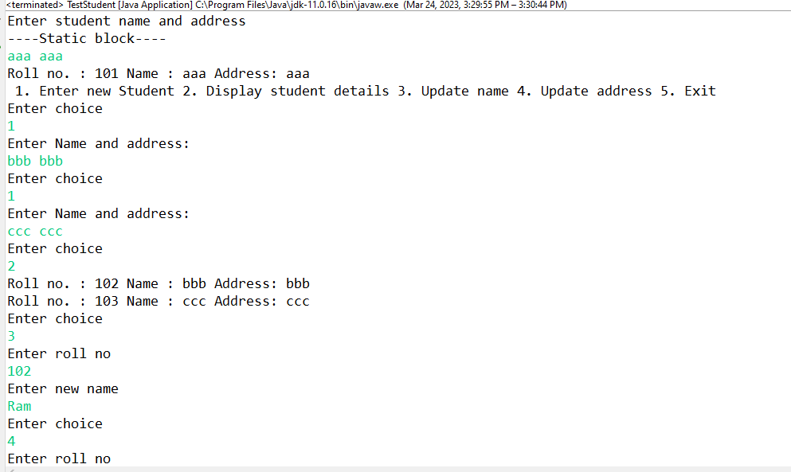

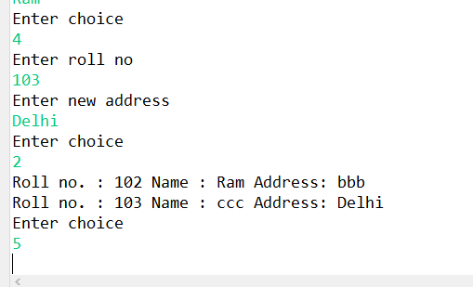

7:Create diff package and add class inside that.

Try to access one package class in another package....

(chk default access specifier)